

PRODUCTS LIST / CATALOGUE
MEDICAL
S.NO | ITEM | TECHNICAL  EXPLANATION | REMARKS | IMAGES WITH  PACKING | IMAGES OF  PRODUCTS
1 | SURGICAL COTTON ABSORBANT , BLEACHED, UNBLEACHED | Rolled surgical cottons  Size Available: Rolls of (10g), (25g), (50g), (100g), (300g), (500kg) or  custom sizes.  sterilization: gama radiation or EO - sterilization | Packing: wrapped in moisture- proof paper.  Need to confirm th size | 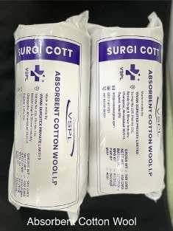 | 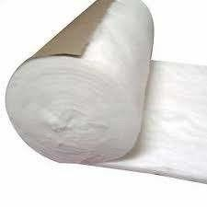
2 | BANDAGE GAUGE CLOTH | Material used: cotton gauze  Size Available: Rolls of (5cm x 3m), (7.5cm x 3m), (10cm x 3m), (15cm x 3m)  sterilization: gama radiation or EO - sterilization | Packing: EO sterilaziation compactable pouches or flow wrapping or wrapped with Medical grade wrapper.  Need to confirm the type and Size. |  | 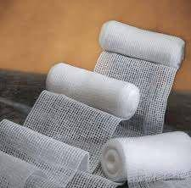
3 | COSMETIC BALLS | Material used : Absorbant cotton Size Available: (3 cm), (4 cm), (5 cm)  Sterilization: UV or gamma radiation | Packing:  Individually packed in plastic or pouches for hygiene (or)  Bulk packed in bags or cartons containing 100, 200, or 500 balls.  Need to confirm the type and size. | 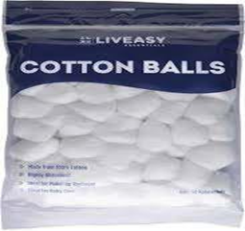 | 
4 | GAUGE SWAB | Types: 1) Amaricn fold 2) French fold .  Types of folds: 8, 12, 16 fold.  Size avilable : 5 cm x 5 cm , 7.5 cm x 7.5 cm and 10 cm x 10 cm | We need to choose the type and number of fold. | 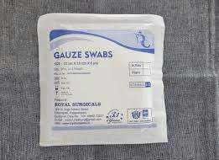 | 